INTERNSHIP REPORT

VINTERN

INTERN

REPORT

Name : UPENDAR THOTA.

Domain : Frontend web Developemnt

Duration : 2 month.

TASK**:[VIA0002] E-commerce app with payment** **integration**

**Target-4: Payment page Design**

ABSTRACT

In the digital age, e-commerce apps have become an indispensable part of our daily lives, enabling consumers to shop conveniently from the comfort of their homes or on the go. This abstract encapsulates the core features and functionality of an e-commerce app with payment integration, showcasing its role as a pivotal conduit for modern retail..

Users can add items to their virtual shopping cart with a single tap, effortlessly managing their selections before proceeding to the checkout process. The payment integration component ensures a smooth transition from product selection to payment completion.

Security is a paramount concern. The app integrates various secure payment methods, including credit and debit card transactions, digital wallets like PayPal, and other trusted third-party payment gateways. Users can confidently complete their purchases with the assurance of data encryption and robust security measures in place.

The app's responsive design ensures it functions flawlessly across various devices and screen sizes, accommodating both mobile and desktop users. Cross-platform accessibility allows users to transition seamlessly between the app and the website, maintaining a consistent experience.

The app features accessible customer support channels and an integrated feedback system to address user concerns promptly and enhance customer satisfaction. This loop of communication helps in continuous improvement.

**INTRODUCTION:**

I used a **HTML , CSS , JAVASCRIPT , BOOTSRAP to create this front end project (ecommerce) .This website seems to be user friendly I created it more responsive .**

**Introducing our cutting-edge e-commerce app with seamless payment integration. Experience a revolutionary shopping platform that combines the convenience of online retail with secure, user-friendly payment processing. Shop with confidence, choosing from a vast array of products while benefiting from personalized recommendations. Our responsive, cross-platform design ensures a smooth experience on all devices. Real-time order tracking and transparent notifications keep you in the loop from checkout to delivery. As the retail landscape evolves, our app remains adaptable, offering a modern shopping experience that meets the ever-growing demands of consumers and businesses. Welcome to the future of e-commerce.**

**Task1 : Design a payment page that demonstrates the payment process flow.**

I Created an effective payment page is crucial for a seamless payment process. Here's a design and explanation of a payment page for documentation I prepared.

\*\***Payment Page Design and Explanation\*\***

**\*Header:\***

**1. **Logo and Branding:\*\***  I Placed company logo at the top rightt corner, ensuring brand recognition. The header provides a consistent look and feel with the rest of your site.

**2. **Navigation:\*\*** Include a navigation menu or links to other sections of your website, such as home, products, or customer support. This allows users to easily access other parts of your website.

*Payment Form:*

**3. **Order Summary:\*\***

- I Displayed a clear and concise summary of the user's order. This includes the names, quantities, and prices of selected items

**4. **Billing Information:\*\***

- Request the user's billing information, including:

- Full Name

- Email Address

- Phone Number

- Billing Address (Street Address, City, State/Province, ZIP/Postal Code)

**5. **Payment Method Selection:\*\***

- I Provided options for the payment method, such as Credit Card, Debit Card, PayPal, and other payment gateways. Users should easily understand and select their preferred method.

**6. **Payment Details Entry:\*\***

- Depending on the chosen payment method, prompt the user to enter relevant payment details, such as:

- Credit/Debit Card Number

- Expiry Date

- CVV/CVC Number

- Cardholder Name

**7. **Proceed to Payment:\*\***

- A clearly labeled button, such as "Proceed to Payment," allows the user to advance to the next step in the payment process..

**\*Footer:\***

8. **Back to Shopping:**

- A link or button allows users to return to the shopping or product selection page, making it easy for them to continue shopping if they wish

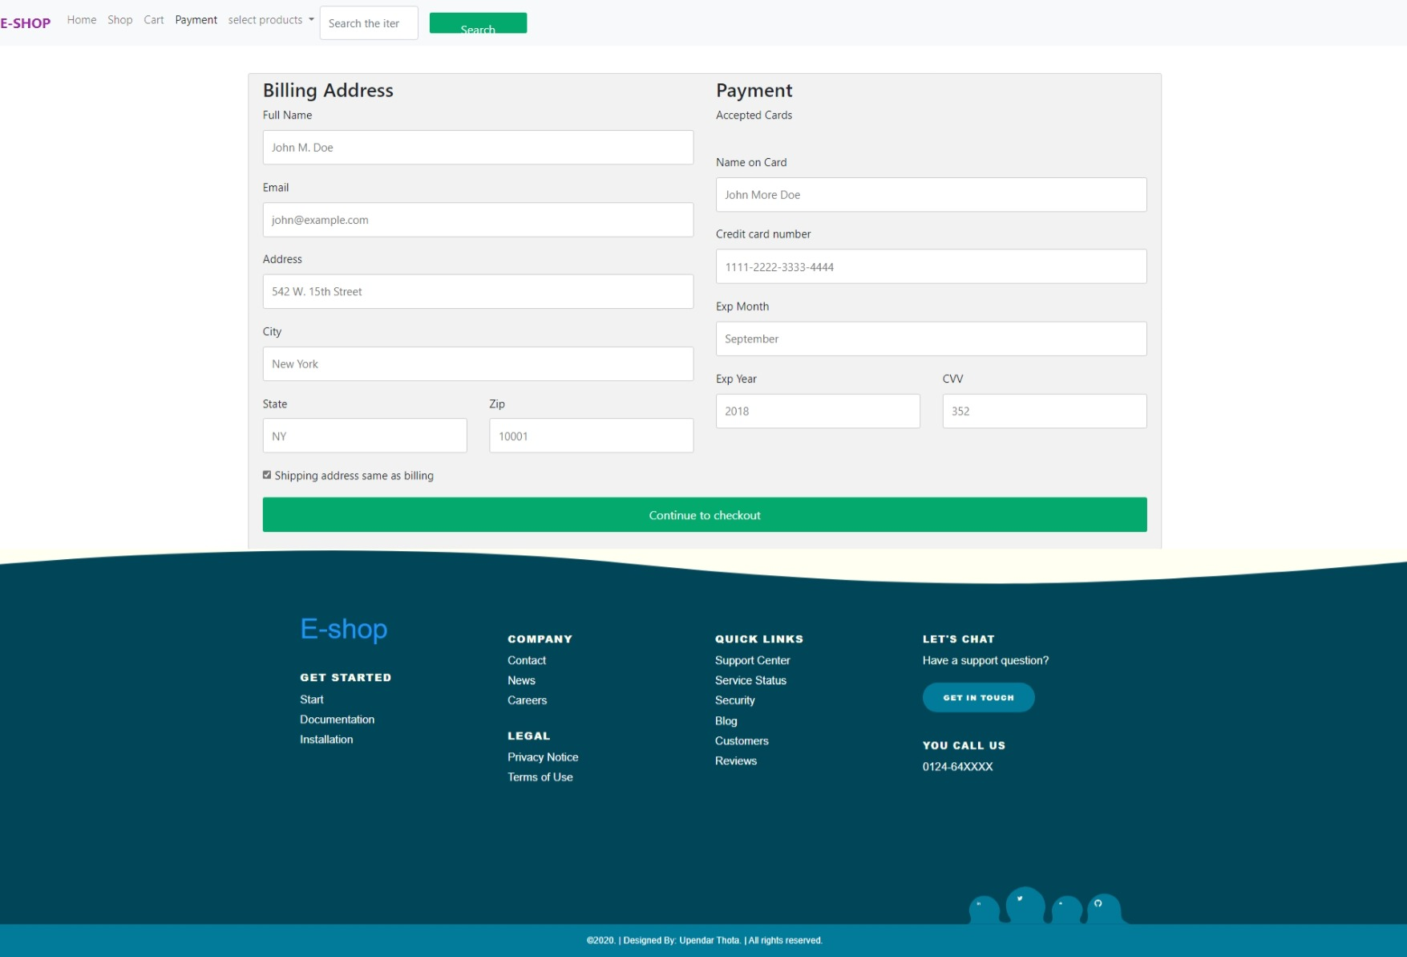

**Task2 : Create a step-by-step visualization of the payment journey without actual payment integration**..

Certainly, here's a step-by-step visualization of the payment journey without actual payment integration, explained in general for documentation purposes:

**\*\*Step 1: Landing on the Payment Page\*\***

- The user arrives at the payment page after selecting items and proceeding to checkout.

**\*\*Step 2: Order Summary\*\***

- On the payment page, the user sees a summary of their order, including the names, quantities, and prices of selected items.

- The "Total" cost of the order is displayed prominently.

**\*\*Step 3: Billing Information\*\***

- The user is prompted to enter their billing information, which includes:

- Full Name

- Email Address

- Phone Number

- Billing Address (Street Address, City, State/Province, ZIP/Postal Code)

**\*\*Step 4: Payment Method Selection\*\***

- The user is presented with various payment method options, including Credit Card, Debit Card, PayPal, and others.

**\*\*Step 5: Payment Details Entry\*\***

- Depending on the selected payment method (e.g., Credit Card), the user enters the relevant payment details, including:

- Credit/Debit Card Number

- Expiry Date

- CVV/CVC Number

- Cardholder Name

**Step 6: Shipping Information (Optional)**

- If the shipping address is different from the billing address, the user can enter a separate shipping address.

- Shipping Address (Street Address, City, State/Province, ZIP/Postal Code)

**\*\*Step 6: Proceed to Payment\*\***

- After filling in the required information, the user proceeds to the next step using a "Proceed to Payment" button.

**Step 9: Confirmation and Review**

- A summary of the order and all entered information is displayed for the user to review.

- The user has the option to edit each section (billing, payment, shipping) if they want to make changes.

**\*\*Step 7: Complete Payment\*\***

- Once the user confirms that the order details are correct, they can click a "Complete Payment" or "Place Order" button.

**\*\*Step 8: Payment Processing\*\***

- During payment processing, a loading or progress indicator is displayed to inform the user that the payment is being processed.

**\*\*Step 9: Back to Shopping\*\***

- A link or button is available for users to return to the shopping or product selection page.

**\*\*Footer Information\*\***

- The footer includes information related to security, assuring users that their payment information is secure.

- Links to terms and conditions and the privacy policy are provided

**Visual Elements and Error Handling**

- The payment page incorporates clear and high-quality visuals, such as icons and images of products.

- A consistent color scheme and responsive design are maintained.

- Error messages and validation are in place to guide users in case of incomplete or incorrect information.

This step-by-step visualization of the payment journey provides a comprehensive overview of the process without actual payment integration. It serves as a useful reference for documentation and can be tailored to match specific business needs and design preferences.

**Task3 : Focus on presenting a clean and user-friendly interface for the payment process..**

**1. **Simplified Layout:\*\***

- I Started with a clean and uncluttered layout that minimizes distractions. I Place important elements such as the order summary, billing information, and payment details in a logical flow.

**2. **Intuitive Navigation:\*\***

-I Make navigation easy by providing a clear and concise header with a navigation menu or links that allow users to access other parts of your website.

**3. **Payment Method Selection:\*\***

- Offer a straightforward choice of payment methods, like Credit Card, Debit Card, PayPal, and more, with clear icons or labels.

**6. **Payment Details Entry:\*\***

- Streamline the input of payment details based on the chosen payment method. Use secure and user-friendly input fields for:

- Credit/Debit Card Number

- Expiry Date

- CVV/CVC Number

- Cardholder Name

**7. **Clear Action Buttons:\*\***

- I Use descriptive and actionable buttons, like "Proceed to Payment," "Complete Payment," or "Place Order," to guide users through the process.

**8. **Receipt and Contact Information:\*\***

- Provide a user-friendly receipt that can be printed or emailed for reference. Include contact information for customer support or inquiries.

**9. **Footer Information:\*\***

- Reiterate the security of the payment process with SSL certificates or trust badges to build trust with users.

**10. **Back to Shopping:\*\***

- Offer a straightforward link or button for users to return to the shopping or product selection page, enabling them to continue their shopping journey.

It is a clean and user-friendly payment interface minimizes friction and enhances the user experience and it ultimately increasing the likelihood of successful transactions and customer satisfaction. Customization should be done according to your brand's style and user preferences, with a strong emphasis on responsiveness and accessibility.

**CONCLUSION:**

In conclusion, an e-commerce app with payment integration has revolutionized the way we shop, offering a streamlined and secure platform for both consumers and businesses. It empowers users to explore, select, and purchase products or services with ease, all within a digital ecosystem that prioritizes convenience, security, and personalization.

I concluded that I created as per tasks for e-commerce project and some more changes are changing until the project has been ended .

I assure the I create more attractive in another targets and I create it more beautiful using frameworks.

I gain great knowledge for creating a page of ecommerce .I Iearn other skill and I will assure that I work on this project to create it more attractive as I known skill .

I Created a user friendly Payment page of step by step Process and the payment integration is understandable way and make user more attractive for shopping to attract to this site.

**NOTE:**

**I** Created a Website previous changes I had changed a cart page ,I added a quantity to increase products and details of product and I added a image to view and identify the image in cart page. And a cart page should open the any link in by clicking the nav-bar icon (cart-icon).

I covered all the major to this front end project of ecommerce and I changed all the remarks to previous tasks of this frontend project .

I gain a great knowledge of this project on frontend technology using **HTML,CSS,JAVASCRIPT,BOOTSTRAP.**

Thank you ….!